Design thinking for software engineering

Situation 5: Job portals provide little feedback to rejected candidates

Lab 2 Report
Name: Ashish Mishra Roll No.:24BTCE185

Target User
Age: 22–25 years (freshers and early-career candidates)
Education: Undergraduate / Graduate / Final-year students
Employment Status: Actively seeking jobs / internships
Platforms Used: LinkedIn, Naukri, indeed, company career portals
Experience Level: 0–3 years
Frequency of Use: Applies to multiple jobs actively

Initial Assumptions
Assumption ID | Assumption
A1 | Freshers and early-career candidates are more affected by lack of feedback than experienced professionals.
A2 | Candidates repeatedly make the same mistakes due to absence of clear rejection reasons.
A3 | Many candidates hesitate or fear applying for new jobs due to repeated rejections without feedback.
A4 | Lack of feedback causes frustration, emotional stress, and reduced motivation among job seekers.
A5 | Many candidates stop or reduce usage of job portals due to poor feedback experiences.
A6 | Job portals and companies avoid providing detailed feedback because they handle a very large number of candidates, making personalized feedback difficult and time-consuming.
A7
  Job portals are designed mainly to connect employers and candidates, not to support post-rejection learning.

Interview Questions
- How would you describe your overall experience of applying for jobs through online job portals?
- What do you usually tell others about the responses you receive after applying for jobs online?
- What usually comes to your mind when you receive a rejection without any explanation?
- What difficulties do you think prevent companies or job portals from providing feedback to every rejected candidate?
- How does repeated rejection without feedback impact your confidence while job searching?
- How do poor or missing feedback experiences affect your motivation to continue applying for jobs?
- What steps do you usually take after receiving a rejection with no feedback?
- Have your job-search habits changed because of poor or missing feedback? If yes, how?

Interview notes and Quotes
Name: Nabal Mishra
Age: 26
Occupation: Service
- Online job portals are convenient but feel impersonal and frustrating due to lack of responses.
- Most applications receive no reply or only automated rejection messages.
- Absence of feedback creates confusion and self-doubt about what went wrong.
- High application volume and limited resources are believed to prevent companies from giving feedback.
- Repeated rejection without feedback reduces confidence and motivation.
- The job search process feels exhausting and discouraging over time.
- After rejection, the user revises their CV and application approach.
- Poor feedback experiences lead to more selective applications and greater focus on networking.
Quote:
- “Most applications don’t get a response, and even rejections give no feedback to learn from”
- “Sometimes you lose motivation because it feels like your effort doesn’t matter”

Name: Aditi Singh
Age: 25
Occupation: Service
- The user’s experience with online job portals is mixed—applications are easy, but the process feels impersonal with limited employer communication.
- Responses after applying are inconsistent, with most applications receiving no reply or only automated rejections.
- Rejections without explanation cause confusion and frustration, making it difficult to understand areas for improvement.
- The user believes feedback is limited due to high application volumes, time constraints, automation, and possible legal concerns.
- Repeated rejection without feedback negatively impacts confidence and leads to self-doubt.
- Lack of feedback also reduces motivation, making the job search feel repetitive and discouraging.
- After rejection, the user attempts to improve by reviewing their resume and seeking guidance.
- Poor feedback experiences have changed job-search behaviour, leading to more selective applications and greater reliance on networking.
Quote:
- “Most of the time I don’t get any replies, even after meeting the job requirements”
- “Online job portals make it easy to apply, but the process often feels impersonal and one-sided”

Empathy Mapping

User 1
SAYS  - Applying is easy but impersonal  - Most applications get no response  - Replies are usually automated rejections | THINKS   - What went wrong?  - Is it skills, resume, or role mismatch?  - Feedback is avoided due to high applicant volume
DOES  - Takes short breaks  - Improves CV and approach  - Applies selectively and networks more | FEELS  - Frustrated and discouraged  - Confidence slowly decreases  - Demotivated and exhausted

User 2
SAYS  - Job portals are easy to use but feel impersonal  - Responses are inconsistent  - Mostly no replies or automated rejections  - Limited communication from employers | THINKS  - Why was I rejected?  - Did I lack skills or experience?  - Feedback is avoided due to high applicant volume  - Automation limits detailed responses
DOES  - Reviews and improves resume  - Reflects on job requirements  - Seeks advice from mentors/friends  - Applies selectively and networks more | FEELS  - Confused and frustrated  - Confidence decreases over time  - Discouraged and demotivated  - Job search feels repetitive

Validate Assumptions
Assumption | Validated (Yes / Partial / No) | Reason
Freshers are more affected than experienced professionals | Partial | Interviews show strong impact of lack of feedback, but no direct comparison between freshers and experienced users.
Candidates repeat mistakes due to no rejection reasons | Partial | Users expressed confusion but also mentioned revising CVs and seeking guidance.
Users expressed confusion but also mentioned revising CVs and seeking guidance. | Partial | Reduced motivation and selective applying were observed, but fear was not explicitly stated.
Lack of feedback causes frustration and low motivation | Validated | Both users reported frustration, emotional exhaustion, reduced confidence, and motivation.
Candidates reduce usage of job portals | Partial | Users did not stop completely but shifted toward selective applying and networking.
Feedback is avoided due to high application volume | Validated | Both users mentioned high volume, limited time, automation, and resource constraints.
Job portals focus on matching, not learning | Validated | Portals were described as impersonal and lacking meaningful post-rejection communication.

Identify User Insights
- Silence creates more anxiety than rejection
- Lack of feedback prevents learning, not effort
- Confidence erodes gradually through repeated uncertainty
- Users tolerate rejection, but not ambiguity
- Impersonal systems reduce trust and engagement
- When platforms don’t guide improvement, users seek support elsewhere
- Emotional exhaustion drives behaviour change more than failure
- Job seekers value clarity and reassurance over application volume

User Persona
User Persona 1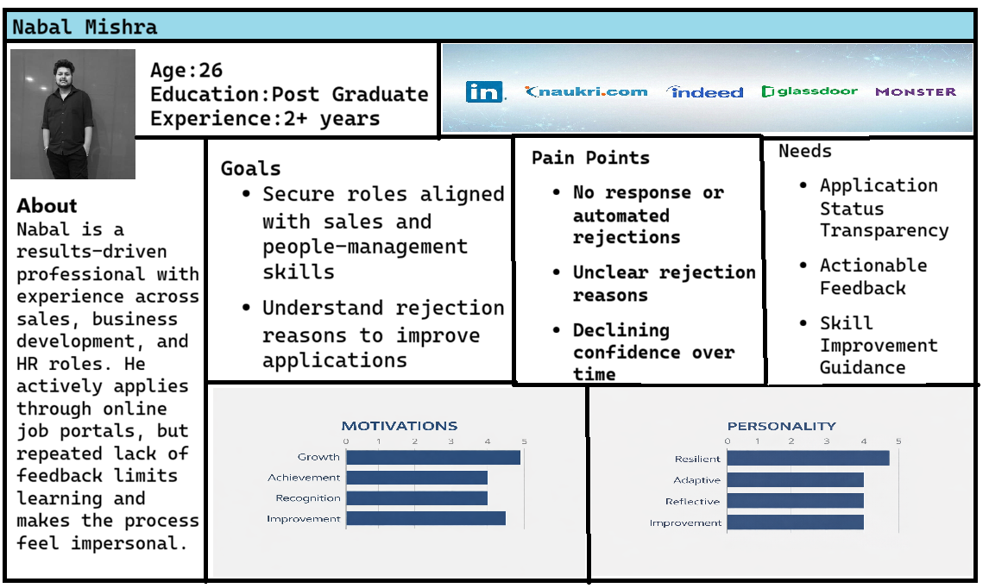
User Persona 2 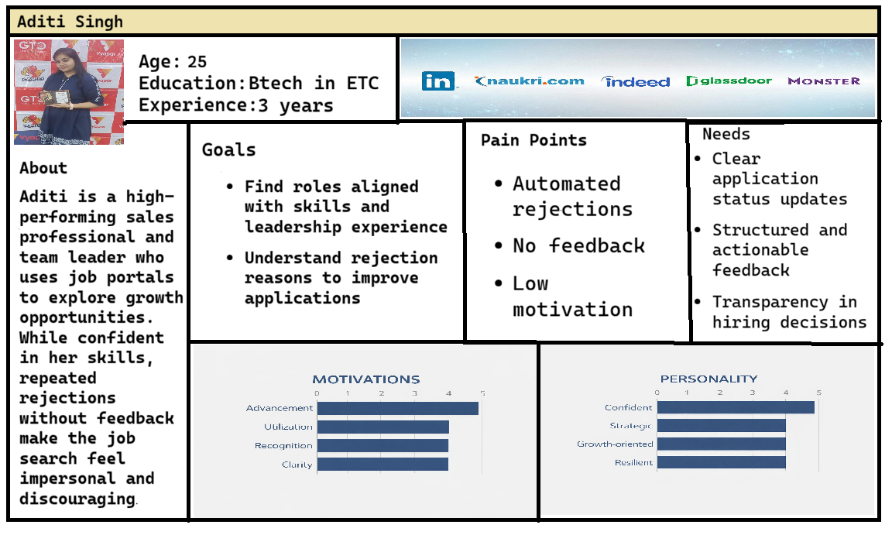

Insights to Software Needs
Insight | Software Requirement
Silence creates anxiety | Mandatory application status updates
Lack of feedback blocks learning | Structured rejection feedback module
Uncertainty reduces confidence | Post-decision guidance messages
Ambiguity frustrates users | Required rejection reason selection
Impersonal systems reduce trust | Personalized notification system
No guidance shifts users away | Skill-gap analysis feature
Emotional exhaustion changes behaviour | Application progress tracking
Clarity matters more than volume | Centralized application dashboard

Reflection & Documentation
- What surprised you during the interview?
Ans: What surprised me during the interview was that users understood rejection as part of the process and even empathized with companies handling high application volumes, yet the lack of feedback and communication caused greater frustration than rejection itself.
- Which assumption was wrong?
Ans: The assumption that candidates completely stop applying for jobs due to lack of feedback was incorrect.
The interviews showed that users do not stop applying entirely; instead, they adapt by becoming more selective, improving their applications, and relying more on networking rather than abandoning job portals altogether.
- How did empathy change your thinking?
Ans: Empathy changed my thinking by shifting my focus from system efficiency to the user’s emotional experience.
Instead of viewing lack of feedback as just a process issue, I began to understand how uncertainty, silence, and poor communication gradually reduce confidence and motivation, influencing how users change their job-search behaviour.
- How will this affect your software design approach?
Ans: This will affect my software design approach by prioritizing clarity, reassurance, and learning over speed and automation.
Instead of focusing only on application flow, the design will ensure transparent status updates, meaningful feedback, and guidance that supports users emotionally and helps them improve after rejection.

